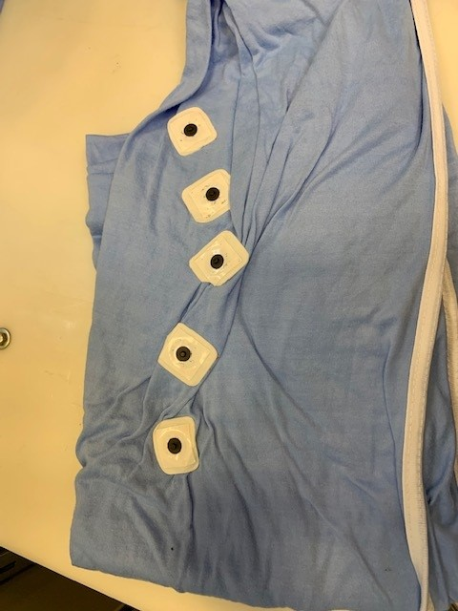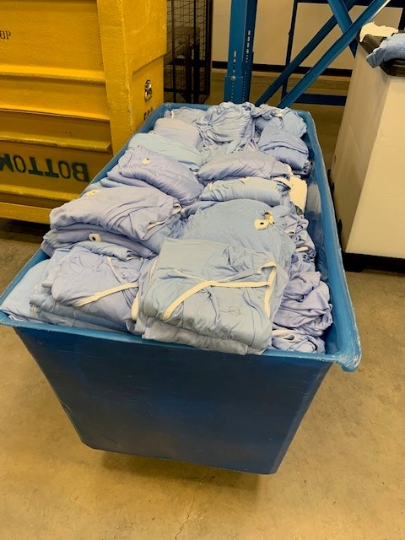

Sticky Leads, Tape & Glue permanently destroy linen in the wash process, please do **not** stick to the bed sheets, isolation gowns and linen. This is costly to the hospitals in replacement linen costs for the laundry.

**Do Not**

**Stick Items to Linen**

*Thank you,*

*Your HCSA*

*Laundry,*

*Customer Service Team.*

